- Create on Bash script to check if a directory is available or not.

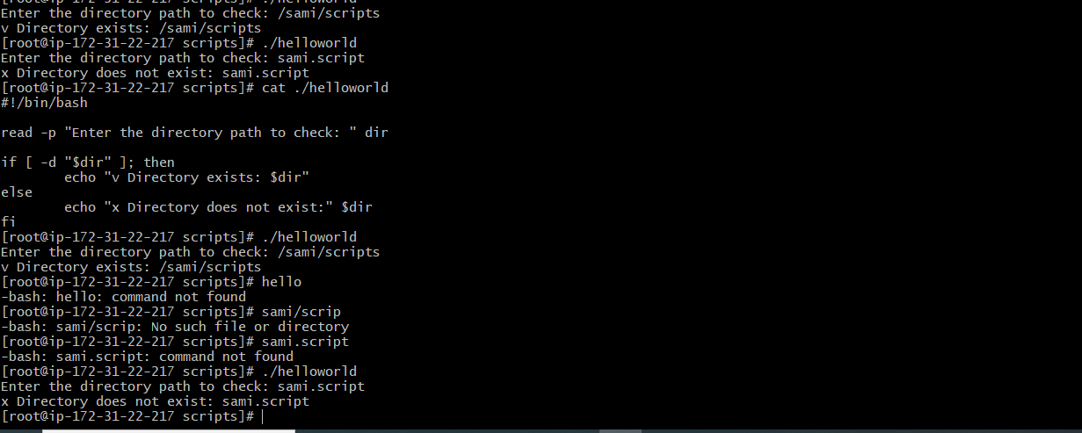

- Create a bash script which will create multiple files.
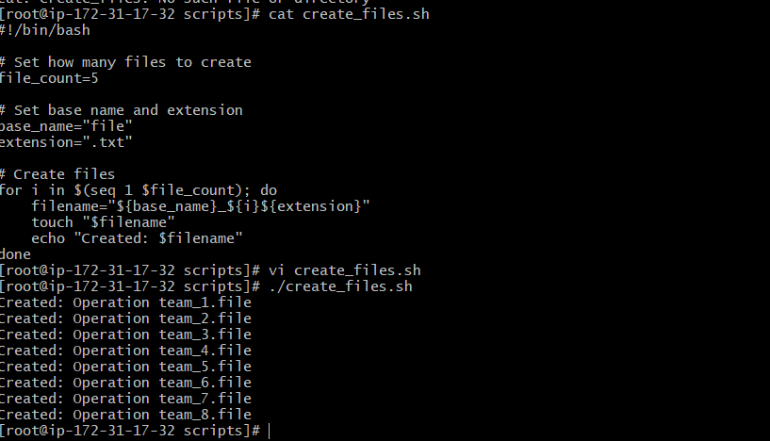

- Create a bash script to take backup of a directory.
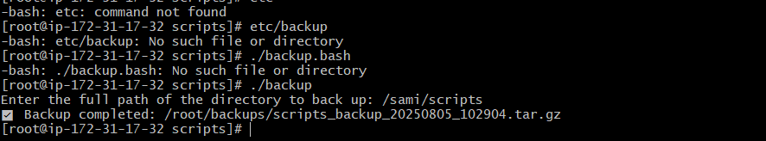

- Create a bash script to install nginx in ec2 server.
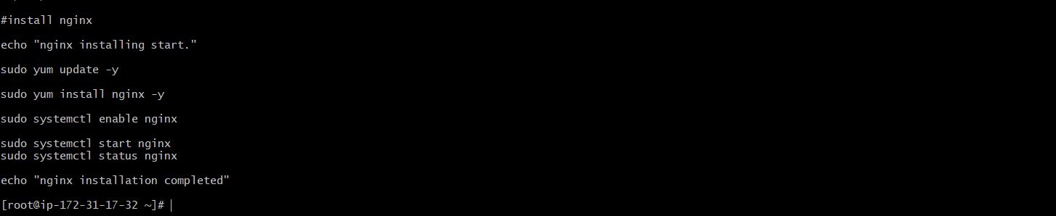
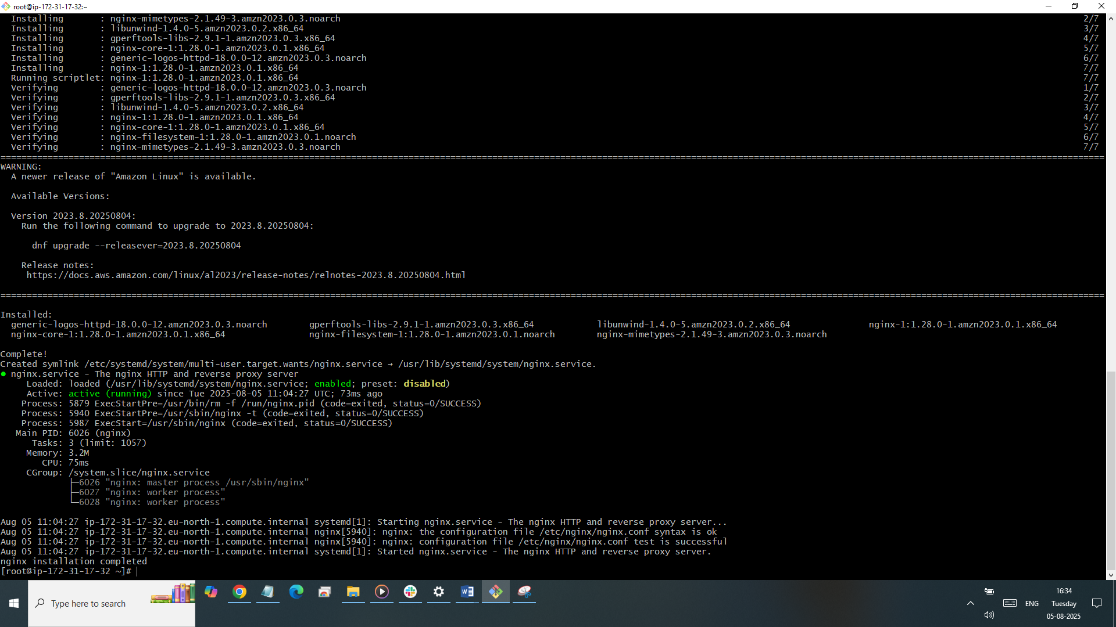

- Create a bash script to install ApacheTomcat in ec2 server.
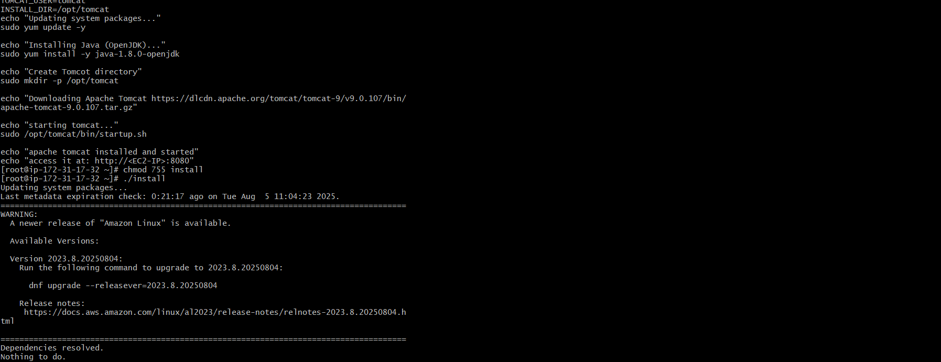

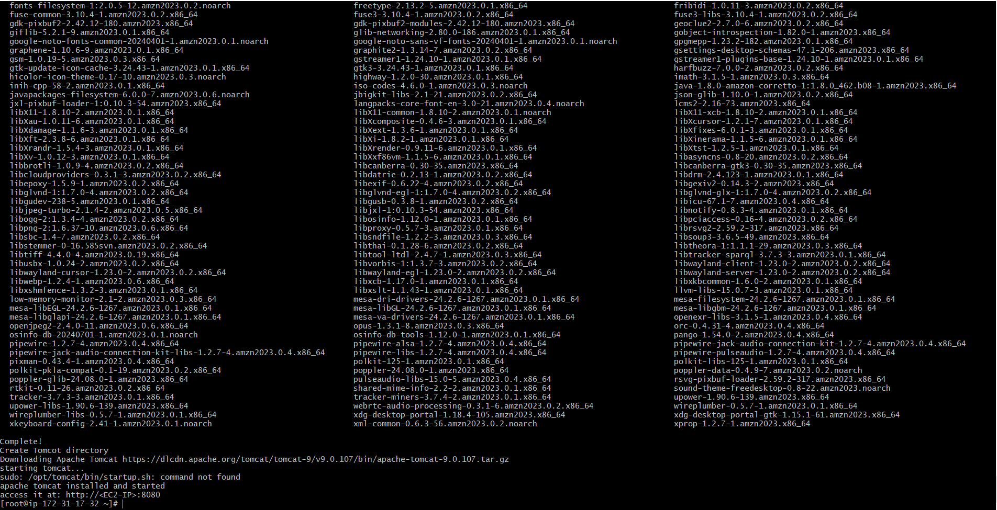

- Create a bash script to check list if nginx service is running or not,if not running
then script should start the service.

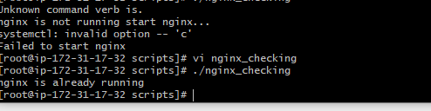

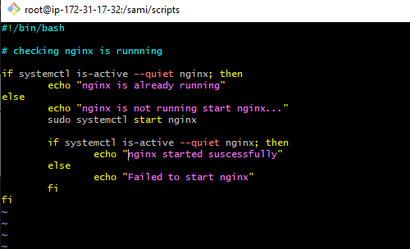

- Create a bash script for calculator.
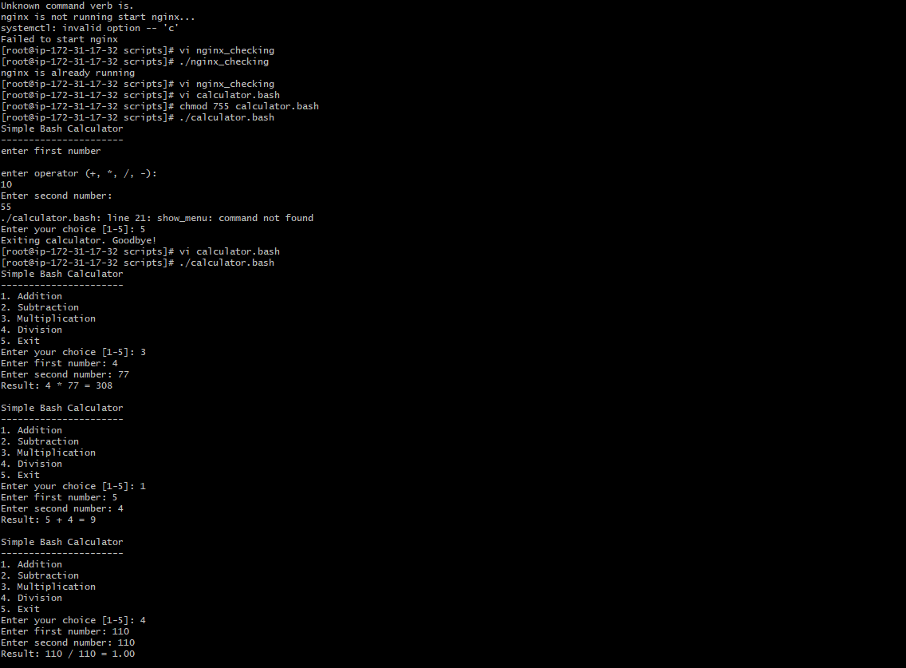

- Create a bash script to check if directory is avaialble or not,if not then create a directory.
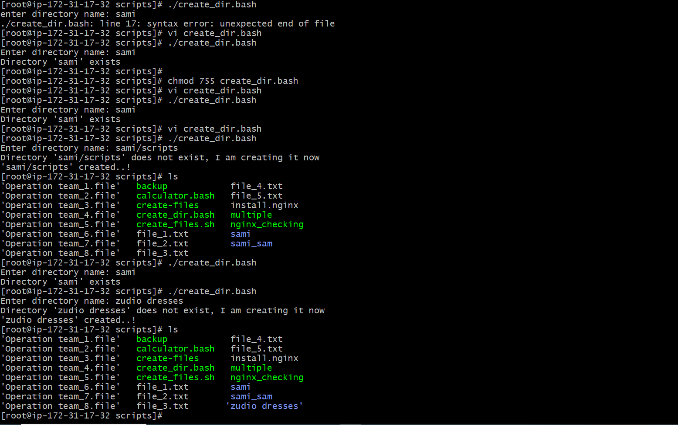

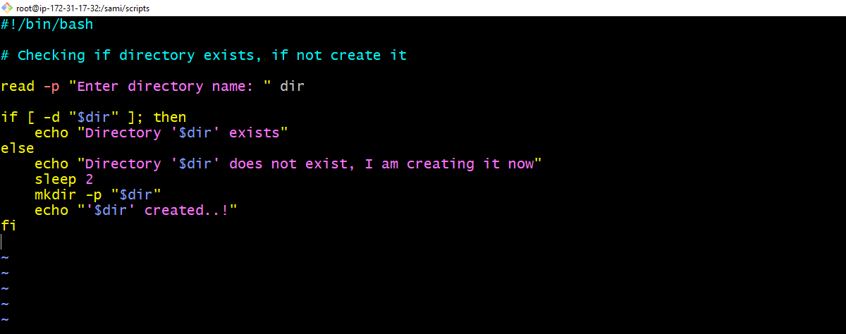

- Create bash script to delete last 3 lines for a file.
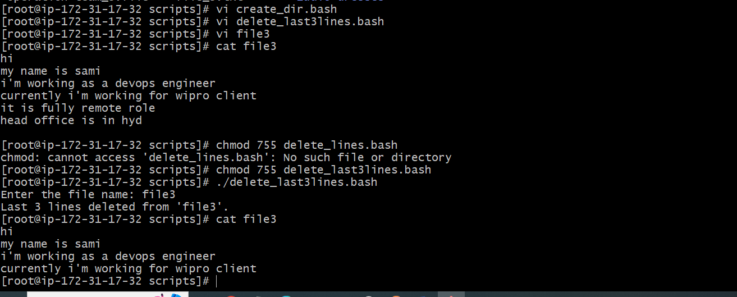

- Bash script to monitor cpu and if it is more than 80% then send email notification.
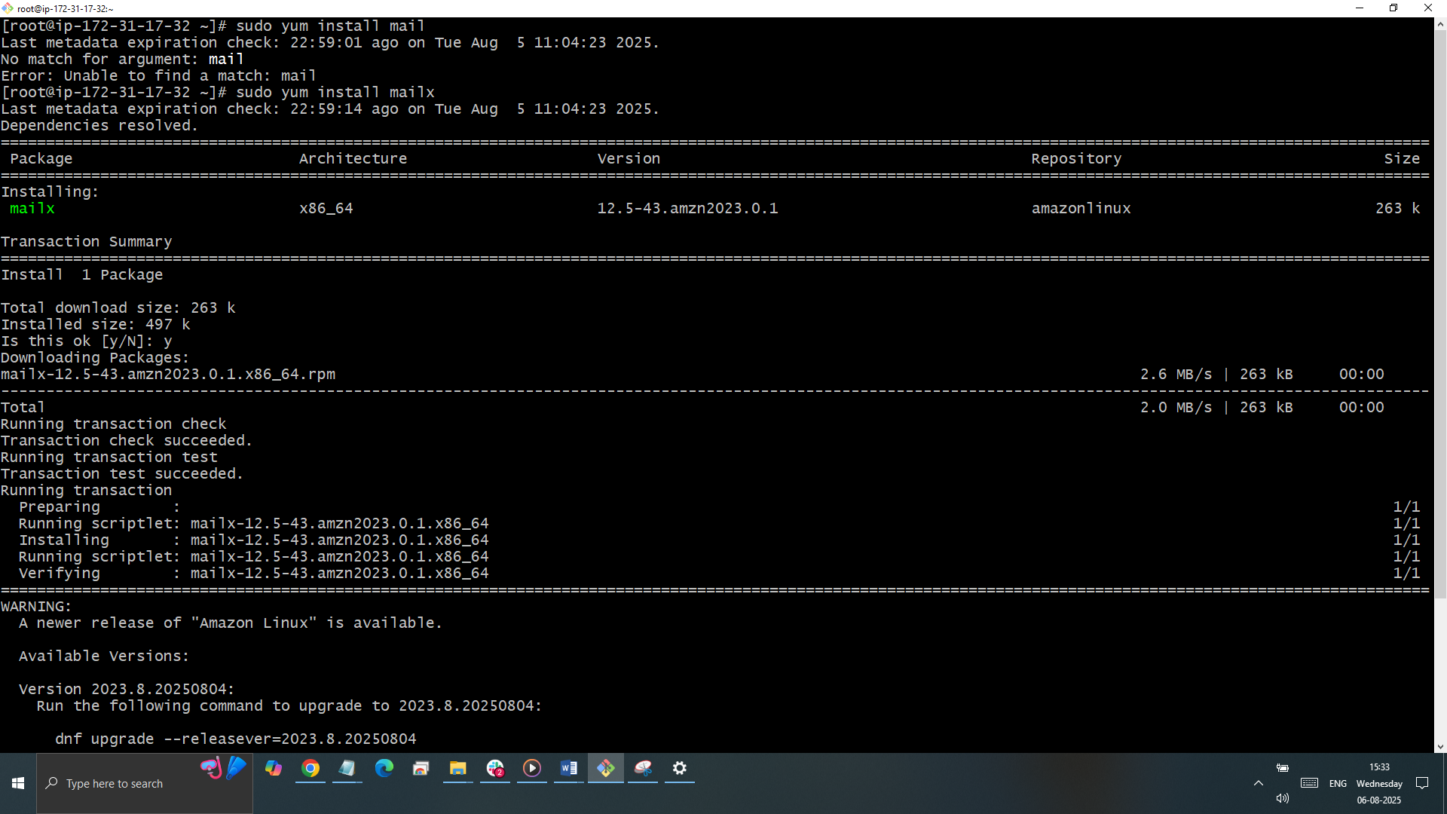
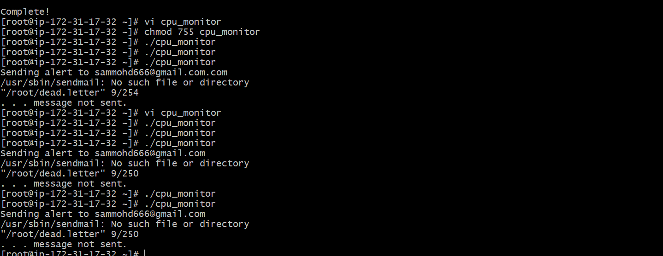

- Bash script to monitor disk space and if it is more than 80% then send email notification.
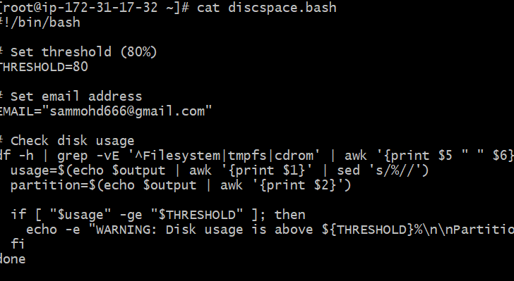

- Bash script to monitor memory and if it is more than 80% then send
email notification.
